Final Presentation:

* TA will MC event and do quick intros of team
* 15-18 mins to present
* Remaining time will be questions from CAs
* All presentations recorded
* All students must have an active role in presentation and be present
* Can invite peers, faculty, and family

Presentation Workshop:

* Preparing for presentation:
  + Identify roles within team and assign sections based on what each person did
    - Each person should be speaking equally; split up who will do intro/conclusion
  + Consider audience
    - Non technical ppl should be able to understand
    - Use visuals, etc
* Slide making:
  + Outline with slide titles and 1-2 line description
  + Coordinate slide template/color scheme
  + Fill in slides
* PRACTICE!
  + Know your slides and what you want to say, but don’t memorize and don't write a script
* Presentation Design
  + Legend of presentation overview visible for everyone
  + Storytelling through slide design
  + Rule of thumb: person should be able to view your slides after and understand the overall idea
    - Visuals are crucial to helping explain idea
  + Tools: haiku, canva
* How to present data
  + Dont just put charts
  + Show a process and describe each chart (legends and titles)
  + Types of data to show: distributions amongst categories
  + Trends over time (if data is temporal)
  + Explain why you’re highlighting certain features
* Presenting your Model
  + Breakdown data transformation stages
    - Cleanup and how you transformed it to be able to use in your model
    - Can use flowchart with icons, etc
    - Show dataframes before and after cleaning (only relevant info)
      * Include code snippets
  + Draw out model architecture
    - Is you used a combo of multiple models: first explain goal of task then describe model used to achieve that subtask
      * Ex: task- predict house prices for next 10 years; model-linear regression
    - Model architecture diagrams
    - Tips:
      * Always show inputs and outputs in between the layers
      * If you used a pretrained model: cite and explain model architecture form paper but also why it;s the most applicable for your use case

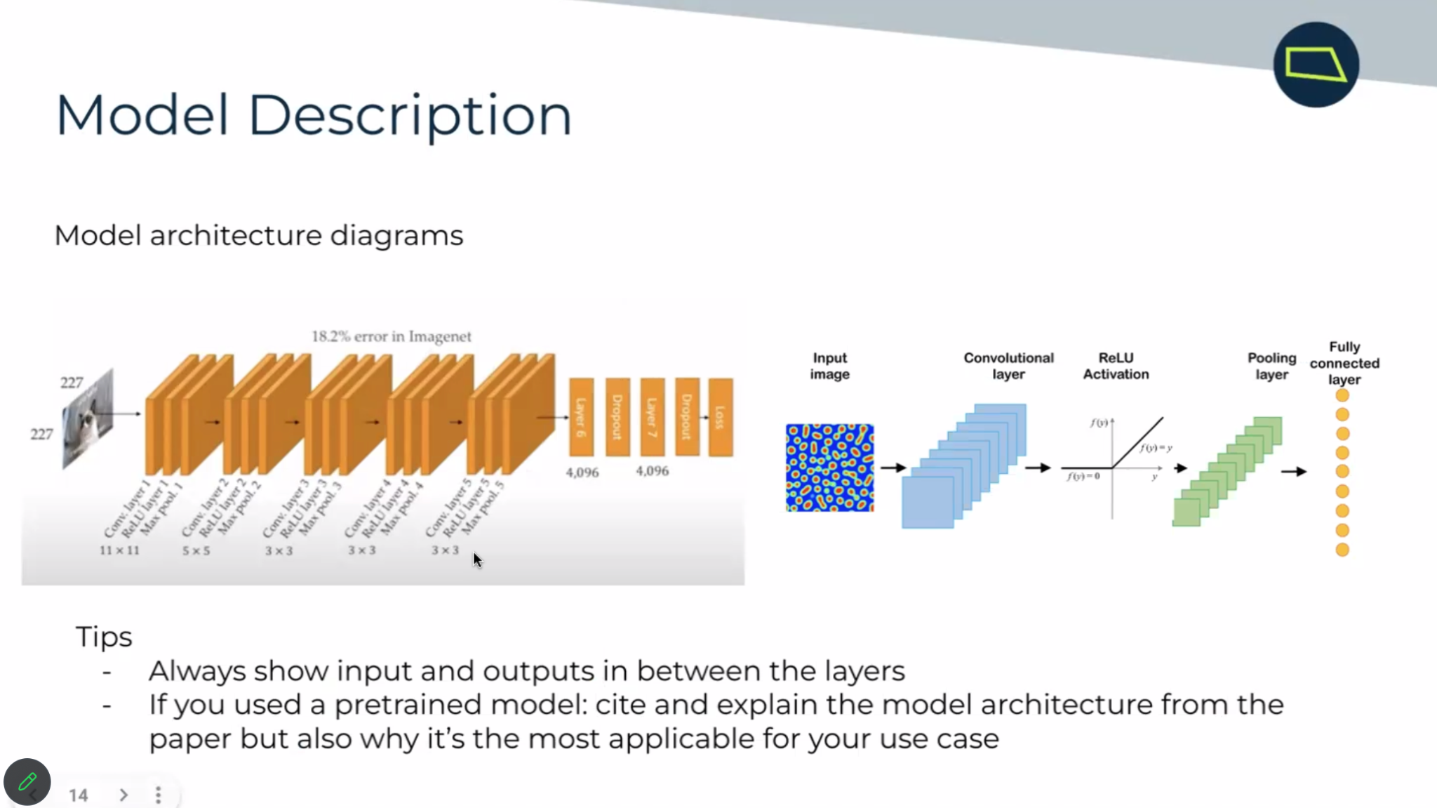

* + Zoom into layers used to construct model and briefly explain role
  + Show results of best performing model
    - Show all models tested but deep dive into best one
    - Confusion matrix, accuracy, f1, etc
  + Conclusion:
    - Start from the top
    - Describe solution
    - Share key findings
    - Tangible next steps for how company could utilize info to achieve goal
      * If synthetic data used, provide examples of how you port real time data within system
    - End presentation with questions
  + Next steps: get better understanding of teams that would work or utilize this in the company so these next steps are tangible
  + Q&A examples:
    - What are metrics of result?
    - How was data acquired and processed
    - What did you find exciting about the challenge
    - Why did you use this particular model in comparison to others
    - Identity tradeoffs and maybe an alternative for doing the project

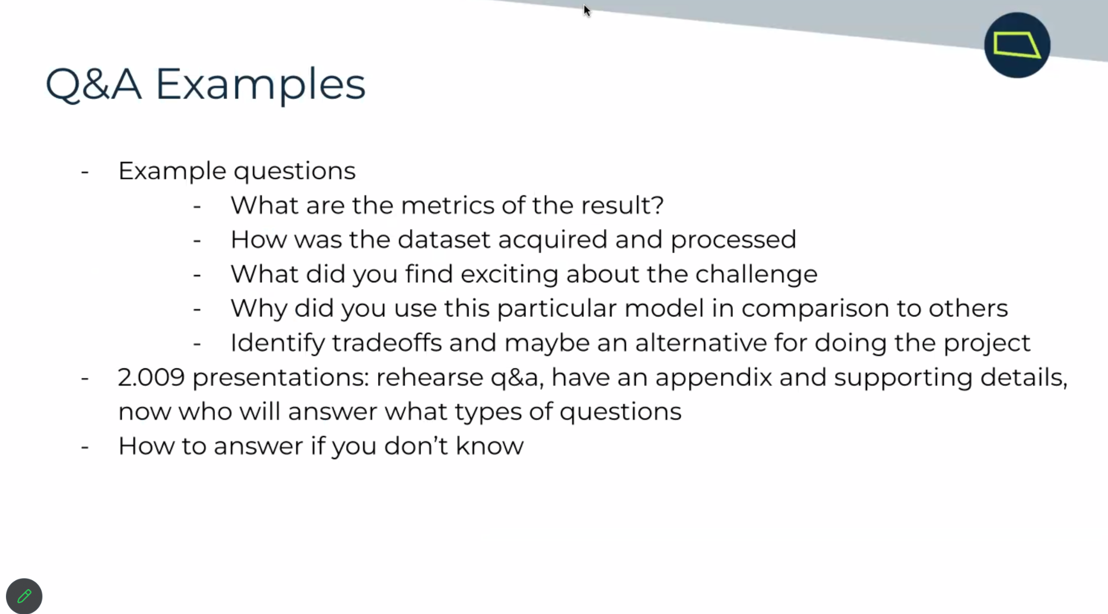

* + Rehearse q&a, have an appendix and supporting details
  + How to answer if you dont know

Team Breakouts:

* png -> jpg
* [nuImages_Test.ipynb](https://drive.google.com/file/d/1WhDxdR5Oxt5UHHxnEOl3gF8VH7n-ttjZ/view?usp=drive_link) code for creating xml files:
  + Filter by cyclists and pedestrians
  + Read in images as .png
  + Then convert to .jpg to reduce file space
  + Write the annotation types and bounding box info to the xml file
* The template Maria uploaded is set up to work on Google Drive but we can change it to work for an HPC if needed
* Use checkpoints to save progress throughout the process
* Where will we put the custom folder structure? Separately or in shared Google Drive
* Data folder -> images and annotations
* Annotations folder -> XML annotations
* Mount drive: make sure path is correct
* Tf record:
  + Label map - extract the class from the png so you don’t have to manually specify (I think?)
  + Maria providing code to generate tfrecord
  + So that tensorflow can have better performance
* Model pipeline config (lowkey got confused here, someone help)
  + In the file of the model architecture that we choose to use (faster RCNN I think): train_config → fine_tune_checkpoint: specify where to save checkpoints, change checkpoint_type to “detection”
* Tensorboard - a visual way to see how training is going
* steps in transfer learning template as I understand them:
  + set up google drive
  + split data into training and test sets
  + create TensorFlow records so TensorFlow knows where the data is and can have better performance
  + Download pre-trained model checkpoint (tbh I don’t understand what this means yet)
  + configure model architecture file
  + train model, use Tensorboard to view progress
  + test model
* Presentation tip from Maria: answer ‘why not just use an existing model, why use transfer learning?’
  + Explain the business problem
* Timeline: get transfer learning done and model evaluation by thanksgiving break; week before thanksgiving break: focus on presentation; final presentation slides due 11/26
* Practice presentation: 1:05-1:25
  + Feedback:
    - ~~“Fine tuning” quote slide~~
      * ~~Is it the best one sentence description of the project?~~
      * ~~Classifying pedestrians and cyclists using transfer learning~~
      * ~~Start with problem (business impact) and then goal~~
        + ~~Focus on transfer learning in goal and why we decided to use it~~
      * ~~Business impact~~
        + ~~Not popularity word choice~~
        + ~~Boost ‘Public trust’ while cutting costs on building model~~
      * ~~Matlab if we use matlab in resource~~s
      * ~~Dataset overview image~~
        + ~~Less text~~
        + ~~Image of car with sensors around car~~
      * ~~Dont need to go into schema details~~
      * ~~Can condense data selection slide into previous slide or use different photo~~
      * ~~Xml~~
        + ~~Picture of xml format~~
      * Explaining what transfer learning is
        + Why its good in a business sense
      * Visually show the model architectures we tried - Have bounding box results lined up and show faster rcnn had the best results
    - Mention change of project/what we achieved
* Final slides due 11/26
  + Ta feedback last round
  + Another practice between 11/26 and 12/04
* Breakthrough tech founder
  + Send malorie email by 11/17
  + On 11/30 2:30-3:00 est in person at MIT
* December 1:1 meetings with mentor
* January 20th, spring AI studio in person at MIT